

Student Name……………………………………

FURTHER MATHEMATICS

WRITTEN TRIAL EXAMINATION 2

2012

Reading Time: 15 minutes
Writing time: 1 hour 30 minutes

Instructions to students
This exam consists of Section A and Section B.
Section A contains a set of extended answer questions from the core, 'Data Analysis'.
Section A is compulsory and is worth 15 marks.
Section B begins on page 8 and consists of 6 modules. You should choose 3 of these modules and answer every question in each of your chosen modules.
Each of the modules is worth 15 marks.
Section B is worth 45 marks.
There is a total of 60 marks available for this exam.
The marks allocated to each of the questions are indicated throughout.
Students may bring one bound reference into the exam.
An approved graphics or CAS calculator may be used in the exam.
Formula sheets can be found on pages 40 and 41 of this exam.
Unless otherwise stated the diagrams in this exam are not drawn to scale.

This paper has been prepared independently of the Victorian Curriculum and Assessment Authority to provide additional exam preparation for students. Although references have been reproduced with permission of the Victorian Curriculum and Assessment Authority, the publication is in no way connected with or endorsed by the Victorian Curriculum and Assessment Authority.

© THE HEFFERNAN GROUP 2012

This Trial Exam is licensed on a non transferable basis to the purchasing school. It may be copied by the school which has purchased it. This license does not permit distribution or copying of this Trial Exam by any other party.

SECTION A

Core

Question 1

This section is compulsory.

The age, in years, at which a group of 16 elderly people left school was recorded. That data is shown in the frequency table below.

Age  (years) | Frequency
9 | 1
10 | 2
11 | 4
12 | 2
13 | 3
15 | 3
19 | 1
Total | 16

- What is the mode of this distribution?

1 mark

An incomplete boxplot was constructed using this data and is shown below.

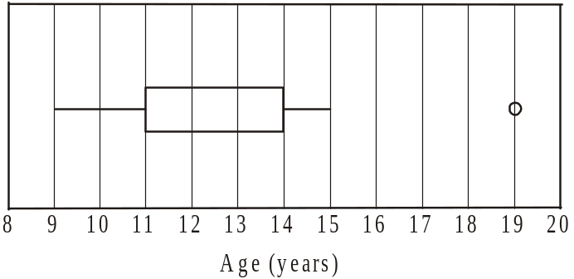

- The line indicating the median has been left off this boxplot. Draw in the median line for this data.

1 mark

- The data value 19 has been shown as an outlier on this boxplot.
Use an appropriate calculation to explain why this is correct.

2 marks
Question 2

A similar, but larger, survey was conducted where adults were asked their age, in years when they left school, together with the location of the last school they attended.
The results, expressed in percentages, are shown in the table below.

Age when leaving school | Location of last school
Age when leaving school | urban | regional | remote
15 | 16.2% | 27.6% | 40.6%
16 | 24.3% | 31.4% | 37.1%
17 | 30.6% | 19.5% | 10.3%
18 | 26.5% | 20.2% | 11.6%
19 | 2.4% | 1.3% | 0.4%

- Of those who last attended a regional school, what percentage left before the age of 18?

1 mark

- Explain whether or not the data supports the idea that there is an association between the age at which a student leaves school and the location of their last school.
Use appropriate percentages (from one age group is sufficient) to justify your answer.

2 marks

Question 3

The age, in years, at which 12 adults left school and the age, in years, at which their mothers left school are shown in the table below. The data is also represented in the scatterplot shown below.

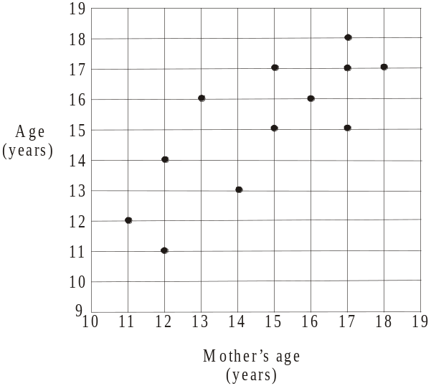
Age  (years) | Mother’s age  (years)
13 | 14
17 | 15
15 | 15
17 | 17
16 | 13
14 | 12
18 | 17
17 | 18
12 | 11
15 | 17
11 | 12
16 | 16

There appears to be a linear relationship between the variable’s age and mother’s age.

- What is the independent variable?

1 mark

A least squares regression line is to be fitted to the data

- Find the coefficients for the equation of this least squares regression line and write them correct to 2 decimal places in the boxes below.

age = + mother’s age

2 marks

- i. Find the coefficient of determination for this data set. Express your answer correct to 4 decimal places.

- Interpret the coefficient of determination found in part i. in terms of the variables age and mother’s age.

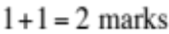

Question 4

The average age in years, at which students left school at intervals of a decade between 1940 and 2000 in a certain country is shown on the time series plot below.
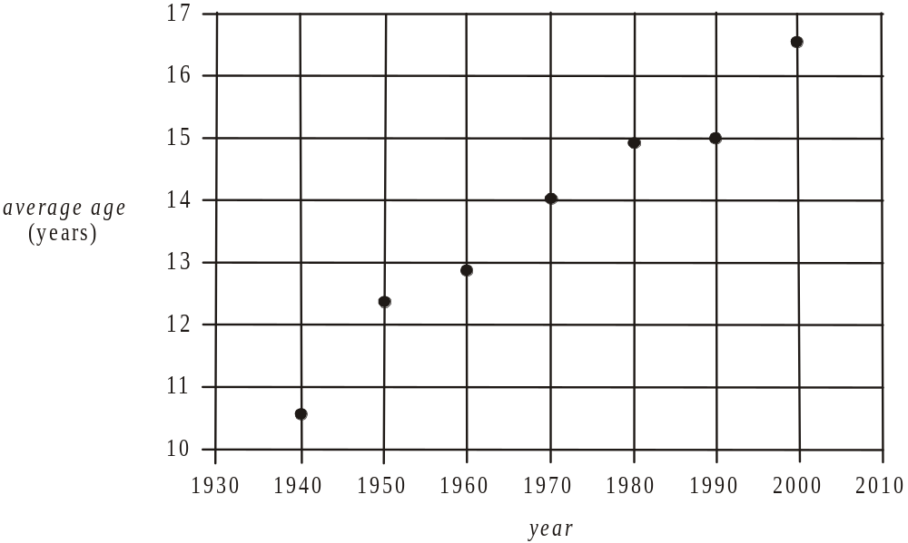

A trend line is fitted by eye to the data. The equation of the trend line is given by

- By how many years does the trend line predict that the average age at which these students left school will increase each year?

1 mark

- The actual average age at which students left school in this country in 1972 was 14.2 years. If the equation of the trend line given is used to predict average age of leaving school in 1972, find the residual for this prediction. Express your answer in years correct to 2 decimal places.

2 marks
Total 15 marks
SECTION B

Module 1: Number patterns

If you choose this module all questions must be answered.

Question 1

Traffic cones are used to guide traffic during road works. The distance, in metres, of each of the cones from the start of the road works forms an arithmetic sequence.
The graph below shows the distance from the start of the road works of the first and fourth cones.

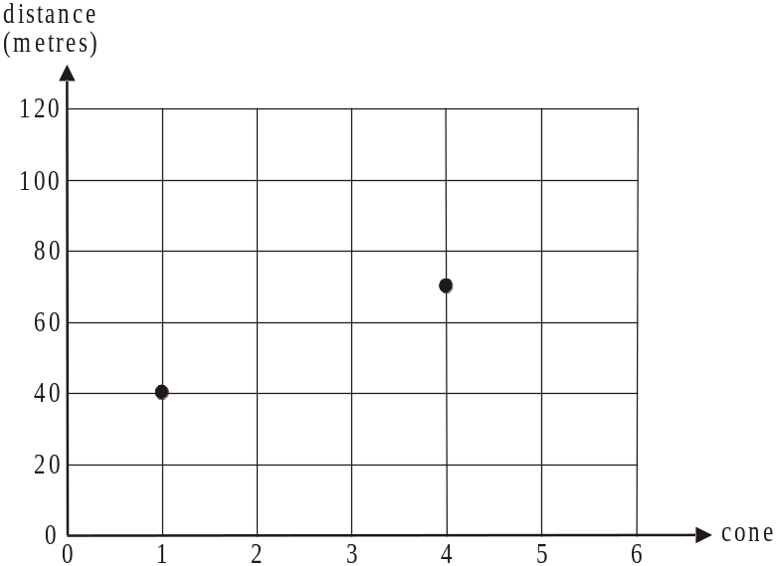

- On the graph above, plot the points representing the distance to the second and third cones from the start of the road works.

1 mark

- What is the common difference for this arithmetic sequence?

1 mark

- When a car had travelled 700m in the road work zone, which cone was it next to?

1 mark

- Road works ended at the 98th cone. Over what distance did the road works extend?

1 mark

- A worker parks his truck at the start of the roadworks and walks to pick up the first cone and then returns it to the truck. He repeats this process for the second cone, the third cone and so on until he has returned the 18th cone to the truck. What is the total distance this worker has walked?

2 marks

Question 2

On a freeway, plastic barriers are joined end to end in order to divert traffic during road works. A water tanker is used to fill the barriers with water. The driver, realizing he is running short of water fills the first barrier in the line with 200 litres of water and fills each barrier after this with 80% of the amount put in the previous barrier.

- How much water will be put in

- the second barrier?

- the tenth barrier? Express your answer correct to 1 decimal place.

- The driver fills one of the barriers with approximately 7 litres of water. Which barrier is this?

1 mark

- If the driver continued filling the barriers in this way indefinitely, how much water would he use in total?

1 mark

Question 3

In another section of freeway where a different line of plastic barriers has been placed, the amount of water 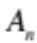 put in the n^{th} barrier in the line, is given by the difference equation

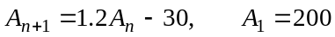

- Find the amount of water, in litres, put in the 4th barrier in the line.

1 mark

- Which is the first barrier in the line to have 20 litres more water put in it than the previous barrier?

1 mark

Suppose that the amount of water put in the n^{th} barrier in the line was given by the difference equation

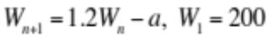

where a is a constant.

- Find the value of a so that each barrier receives the same amount of water.

1 mark

Question 4

A road work crew on a country road has a shortage of traffic cones. This means that cones have to be laid out so that the distance of each cone from the start of the road works is 5% further on than the distance of the previous cone from the start plus an extra 10 metres.

The first cone is 70m from the start of the road works.

- What is the distance of the second cone from the start of the road works?

1 mark

- Let 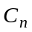 be the distance in metres of the nth cone from the start of the road works.
Using 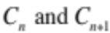, write a difference equation that can be used to generate the distance of each successive cone from the start of the road works, beginning with the first cone.

1 mark
Total 15 marks

Module 2: Geometry and trigonometry

If you choose this module all questions must be answered.

Question 1

In Figure 1 below, the side-on view of a lecture theatre is shown. Tiered seating runs between points A and C. The angle ACB is , the distance from the front wall to the back wall of the theatre is 22m and the horizontal floor from point C to D is 6m. Also the distance from point A to point B is 8m.

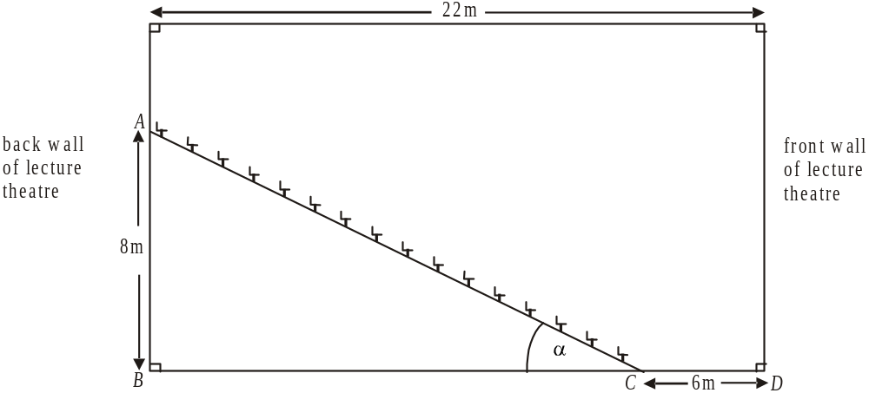

Figure 1

- Find the distance from point A to point C. Express your answer correct to 1 decimal place.

1 mark

- Determine the size of angle in degrees. Express your answer correct to 1 decimal place.

1 mark

Figure 2 below shows light being projected from a point P on the back wall of the theatre to a screen on the front wall of the theatre between points S and T.

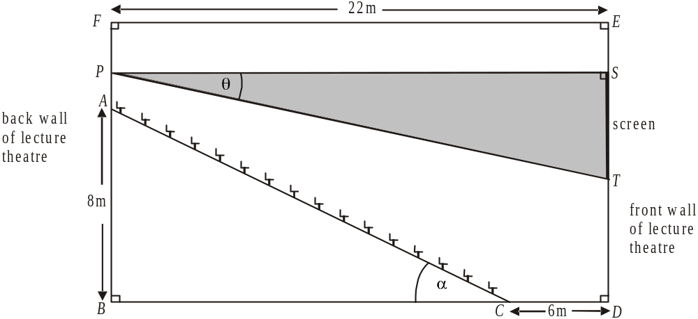

Figure 2

The size of angle SPT is 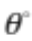, and PS runs parallel to FE and the height of the screen ST is 4m.

- Find the value of . Express your answer in degrees correct to 1 decimal place.

1 mark

- What is the angle of depression of point T from point P?

1 mark

Question 2

In the grounds of a university is a lake with a landscaped area surrounding it. On the contour map below, where the contour line markings are in metres, the lake is shaded and a seat is marked at point S. Point L lies on the edge of the lake.
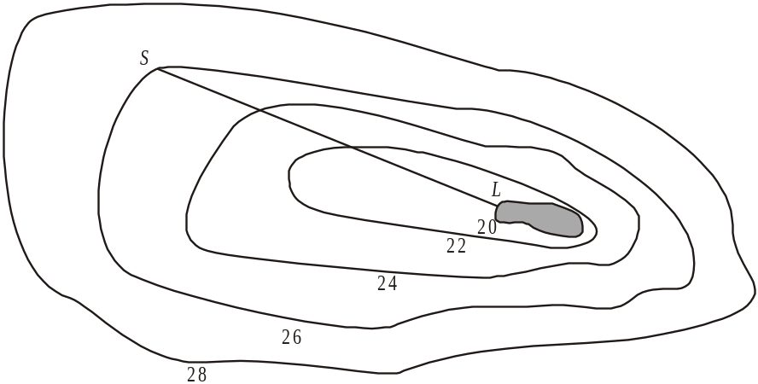

On the contour map, 1 centimetre represents 5 metres on the horizontal level. The distance from point S to point L on the contour map is 6cm.

- A bird sits on the seat at point S. It flies in a straight line and lands at point L. What distance has the bird flown? Express your answer in metres correct to one decimal place.

1 mark

- What is the average slope between the seat and point L?

1 mark

Question 3

Five lecture theatres of identical size and shape are housed in one building which is in the shape of a regular pentagon. The centre of the building contains a storeroom which is also the shape of a regular pentagon as shown in the diagram below.

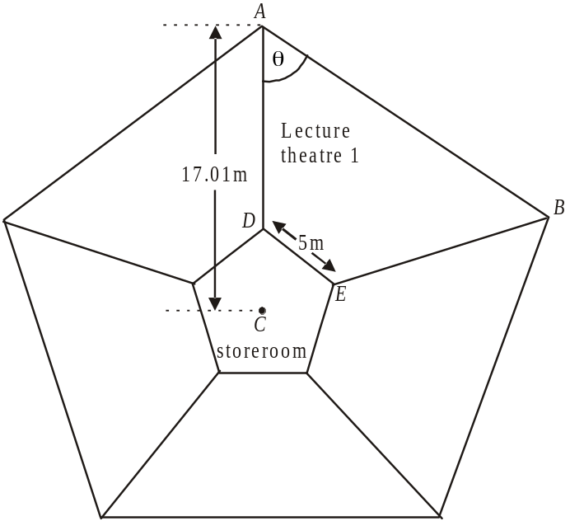

The point C is the centre of the building. In lecture theatre 1, points A and B are at the back corners of the theatre and points D and E lie at the front corners of the lecture theatre. Point D lies on AC. Also, 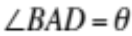; the distance DE is 5m and the distance 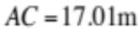 (correct to 2 decimal places).

- Show that the size of angle is 54°.

1 mark

- Find the length of the back wall, AB, of the lecture theatre. Express your answer correct to 1 decimal place.

1 mark

- Show that the distance CD is 4.253m (correct to 3 decimal places).

1 mark

- Find the area of the storeroom. Express your answer in square metres correct to 2 decimal places.

2 marks

Question 4

On a plan of the university campus, the library is located at point L, the student union is located at point S and the administration building is located at point A.

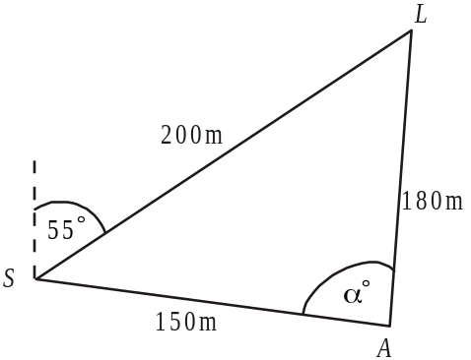

On the plan above,
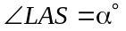and the bearing of L from S is 055°.

- Find the size of in degrees correct to 2 decimal places.

1 mark

- Find the bearing of A from S. Express your answer to the nearest degree.

1 mark

- Find the bearing of A from L. Express your answer to the nearest degree.

____________________________________________________________________
2 marks
Total 15 marks
Module 3: Graphs and relations

If you choose this module all questions must be answered.

Question 1

A courier business runs a service whereby they pick up and drop off documents. The distance between the pick-up point and the drop-off point determines the charge for the service.

distance (km) | charge
0 < distance ≤5 | $10
5 < distance ≤10 | $15
10 < distance ≤15 | $25
15 < distance ≤30 | $45

Jane has a document collected from her home and dropped off at an office 8km away. The next day the document is collected from the office and dropped back to Jane’s home.

- What will be the total charge for both these deliveries?

1 mark

The charges shown in the table above are shown on the graph below.

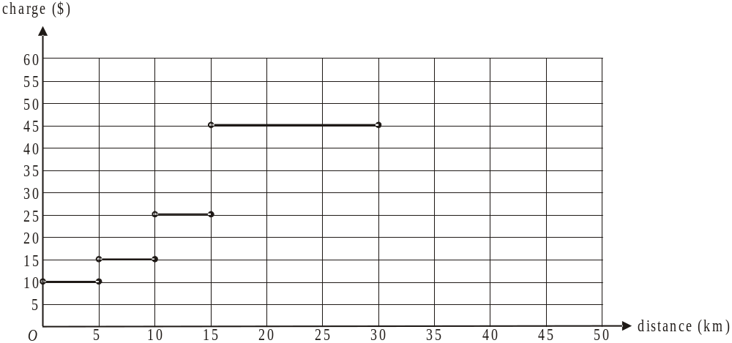

The courier business extends this service to cover distances more than 30km and up to and including 40km. The charge for the service over such a distance is $55.

- Draw this information on the graph above.
1 mark
The courier business decides to change the charges for this document delivery service. They will now charge a flat rate of $5 per pick up and delivery and $2 per kilometre travelled in between.

An equation that gives this new charge is

charge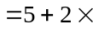distance

- What is the new charge for a document that has to be delivered 14km away?

1 mark

- Between which distances over 15km are the new charges cheaper than the old charges?

2 marks

The courier business takes on a new manager who proposes to change the charges again.
The graph below shows a line representing his proposed charges.
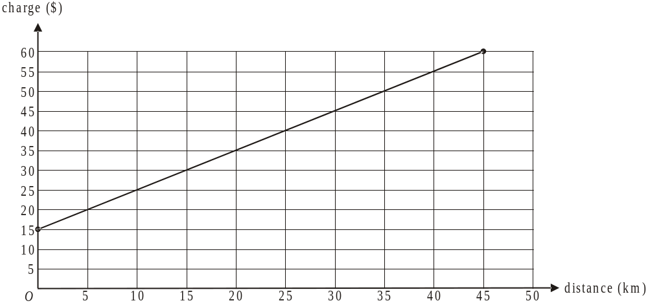

The equation that gives his proposed charges is 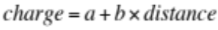.

- Find the values of a and b.

1 mark

- What is the maximum distance that the courier business will deliver documents to according to the new manager’s proposal?

1 mark

Question 2

The courier business also has a contract with a large postal service to deliver small (under 10kg) and large (over 10kg) parcels.
The two constraints on the number of parcels that the courier business can deliver occur because of staff and transport limitations.

Let the number of small parcels delivered in a day by the courier business
Let 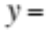the number of large parcels delivered in a day by the courier business

The inequalities below represent the constraints on the number of parcels that the business can deliver in a day.

Constraint 1: 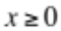
Constraint 2: 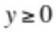
Constraint 3: 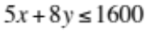 (due to transport limitations)
Constraint 4: 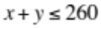 (due to staff limitations)

The graph of 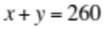 is shown on the graph below.
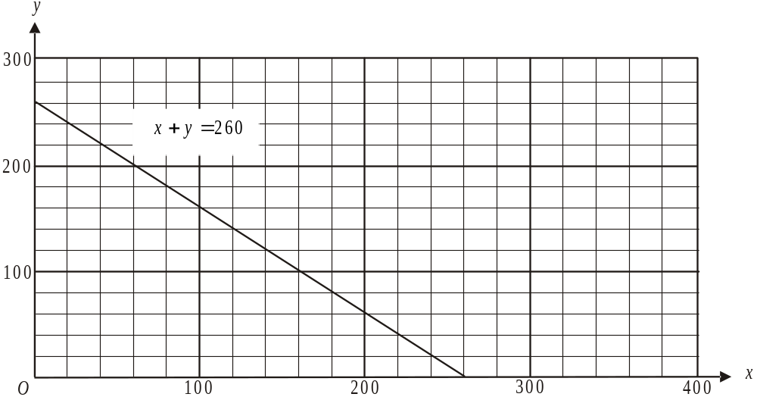

- On the graph above, draw the straight line associated with Constraint 3.

1 mark

- On the graph above, shade the feasible region.

1 mark

The courier business makes a profit of $3.50 for delivering a small parcel and $5 for delivering a large parcel.

- Write down an expression for the profit P, in dollars, made by the business for delivering small and large parcels.

1 mark

- i. What is the maximum profit that can be made by the courier business in a day for delivering small and large parcels?

- How many large parcels must be delivered in a day to achieve this maximum profit?

The courier business is asked by the postal service to change their contract so that they deliver at least 150 large parcels a day. All other constraints remain the same.

As an incentive to deliver more large parcels, the postal service increases the amount paid to the courier service for large parcel deliveries. The profit for the courier business delivering small parcels remains at $3.50 whilst the profit for delivering large parcels is increased to $5.50.

- i. What is the maximum profit that can now be made by the courier business in a day?

ii. How many small and large parcels must be delivered in a day to achieve this maximum profit?

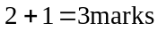
Total 15 marks

Module 4: Business-related mathematics

If you choose this module all questions must be answered.

Question 1

Lucy and Bernie purchased an investment property for $760 000. They had saved 12.5% of this purchase price as a deposit.

- What was the amount of their deposit?

1 mark

- The stamp duty that they had to pay on this purchase was $40 670. What percentage of the purchase price was the stamp duty?
Express your answer correct to 2 decimal places.

1 mark

Lucy and Bernie held the property for a number of years before selling it for $920 000. They had to pay capital gains tax at the rate of 42%.

- How much capital gains tax did Lucy and Bernie have to pay?

1 mark

Question 2

Bernie purchased kitchen appliances valued at $4 500 for the investment property. He entered a hire-purchase agreement whereby he paid a deposit of $500 and made monthly payments of $180 for 2 years.

- How much interest did Bernie pay in total?

1 mark

- What is the annual flat rate of interest under this agreement?

1 mark

- What is the effective rate of interest?

1 mark

Question 3

Using some of the proceeds from the sale of the investment property, Lucy and Bernie invest $30 000 in an annuity. This means they are paid a regular monthly amount for 3 years whilst Lucy returns to study.
The annuity earns interest at the rate of 4.5% per annum.

- What amount do Lucy and Bernie receive from the annuity each month?

1 mark

- If Lucy and Bernie had received $1000 per month, how long would the annuity have lasted if the interest rate remained the same? Express your answer to the nearest whole month.

1 mark

- If Bernie and Lucy had invested this $30 000 in a perpetuity with an interest rate of 4.5% per annum, what monthly amount would they have been paid?

1 mark

Question 4

When Lucy and Bernie first started looking for their own home to purchase, they transferred $120 000 to an account that earned compound interest of 5.2% per annum compounding weekly. They left this money in that account for 14 weeks.

- How much interest did Lucy and Bernie earn in that time? Express your answer to the nearest dollar.

1 mark

When Lucy and Bernie started bidding at auctions, they moved the original amount of
$120 000 to an at call account that earned simple interest of 3.4% per annum.
This money remained in the account for 9 weeks.

- How much interest did they earn during this time?

1 mark

Question 5

Lucy and Bernie borrow $480 000 to purchase their home. They take out a reducing balance loan and will make quarterly repayments of $11 000 in order to pay the loan out fully after 20 years.

- What is the annual interest rate charged on this loan? Express your answer as a percentage correct to 2 decimal places.

1 mark

- After two years, how much principal will still be owing?

1 mark

- After 3 years, the interest rate increases to 7.25% per annum. The principal still owing on the loan at this time is $442 168.27. If repayments remain at $11 000 per quarter,

- what extra length of time will it take to fully repay the loan? Express your answer to the nearest whole quarter.

- how much interest would Lucy and Bernie pay now over the course of the whole loan?

Total 15 marks

Module 5: Networks and decision mathematics

If you choose this module all questions must be answered.

Question 1

Dan is a plumber and is working on six different worksites A – F. The distance, in km, of the various routes joining these worksites is shown on the network below.

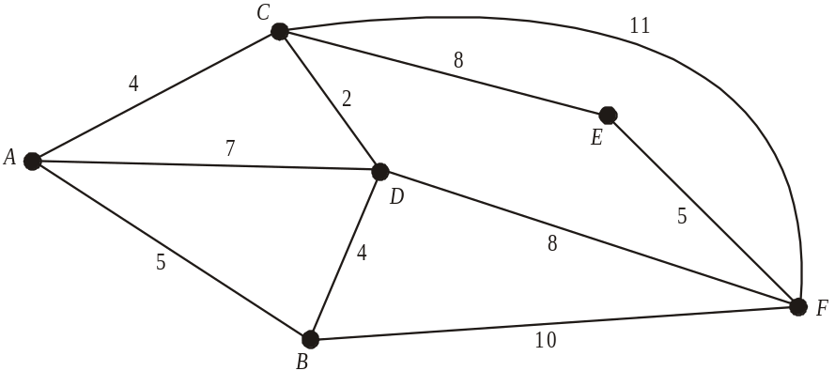

- What is the shortest distance, in km, between worksite A and worksite F?

1 mark

One day Dan starts and finishes his day at worksite A and visits each of the other worksites just once during the day.

- Which mathematical term can be used to describe the route that Dan takes during this day?

1 mark

On another day Dan starts his day at one worksite, finishes at a different worksite and travels along each route shown on the network just once.

- Which two worksites could Dan have started at?

1 mark

Question 2

One of Dan’s worksites is at a retirement village. At this village there is a group of five units that are connected by narrow one-way roadways. The units, numbered 1 – 5, together with the roadways that connect them and the direction in which cars must travel, are shown on the network below.
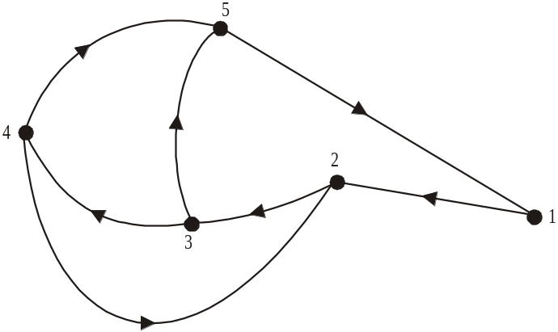

Unit 5, for example, can be reached from Unit 4 in one step. Unit 5 can be reached from Unit 3 in one step or in two steps.
The adjacency matrix shown below gives the number of one-step routes that exist between each of the units.
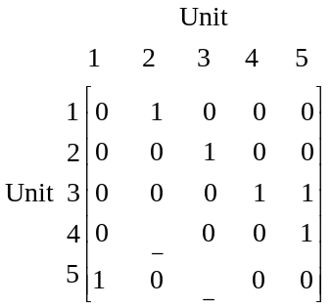

- Complete the adjacency matrix above by filling in the two missing entries.

2 marks

- Taking into account just one-step and two-step routes between the Units, which Unit(s) is/are

the most reachable

the least reachable?

2 marks
Question 3

At the retirement village a landscaped garden features a large area of paving. Surface rainwater flows into two pits in the paving and then flows through a network of pipes which flow into two stormwater drains. The direction of flow together with the flow rate, in litres per second, for each of the pipes is represented on the network below.
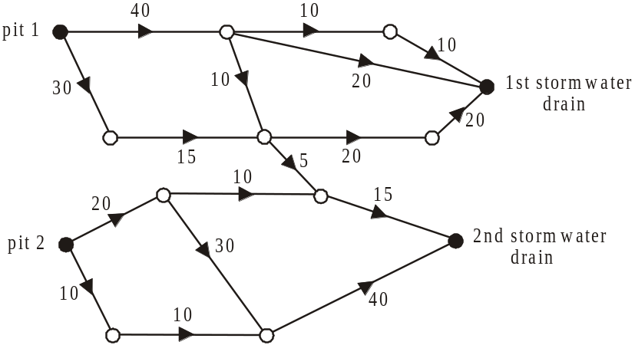

- Find the maximum rate, in litres per second, that water can flow through the network of pipes to flow into the

1st stormwater drain

2nd stormwater drain.

2 marks
The 1st stormwater drain often gets blocked because of a nearby tree.
In order therefore to maximize the amount of rainwater that can run into the 2nd stormwater drain, a new pipe is to be laid as shown in the network below.
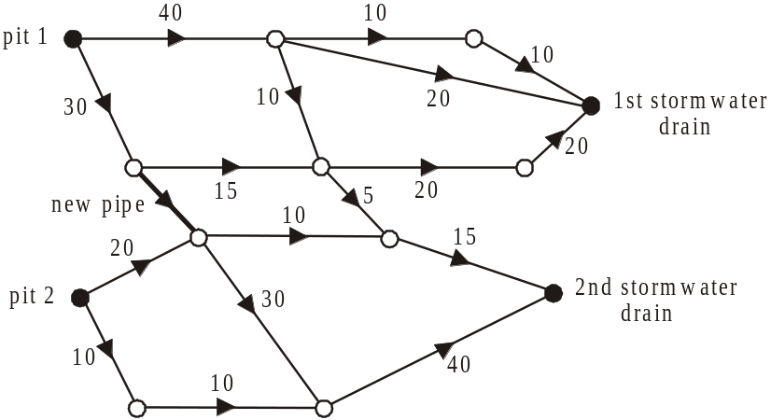

- What is the minimum flow rate that this new pipe should have?

1 mark

Question 4

On one of Dan’s worksites there are 12 activities that need to be completed to finish the project.
These activities A – L, and the time it takes in days to complete them are shown on the directed network below.

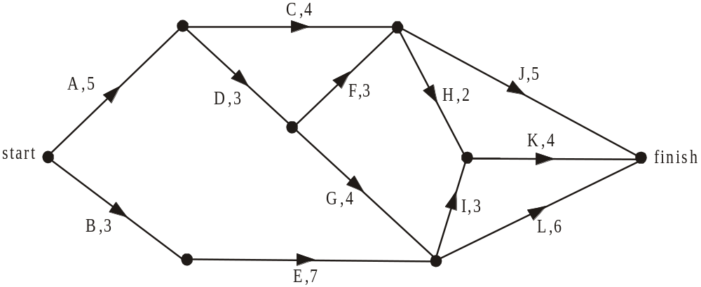

- What is the latest start time for activity F?

1 mark

- Which activities lie on the critical path?

1 mark

A change in design is considered. This change requires an additional activity, M, to be included that has activities E and G as its immediate predecessors. Activity M is not an immediate predecessor to any other activity.

- If the project cannot be delayed by its inclusion, what is the maximum time which activity M has to be completed?

1 mark

It is eventually decided not to include activity M in the project.

In the end, the time taken to complete the project was 1 day longer than the shortest possible completion time. One activity delayed the projects completion by running 4 days late.

- Which activity delayed the project?

1 mark

e. Which activity could have run 4 days late and not delayed the project?

1 mark
Total 15 marks
Module 6: Matrices

If you choose this module all questions must be answered.

Question 1

The diagram below shows a supply chain for a particular product used in the building industry.
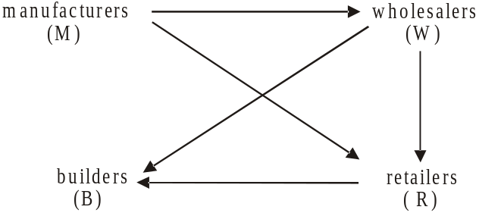

The matrix C for this supply chain is shown below. In matrix C, the “1” in column R, row B indicates that the retailers supply the builders and the “0” in column B, row W indicates that the builders (B) do not supply the wholesalers (W). Matrix C is incomplete.

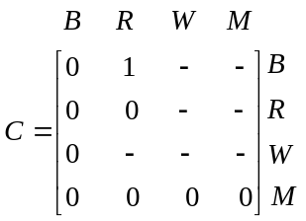

- Complete matrix C by filling in the seven missing elements.

1 mark

- By making reference to builders, retailers, wholesalers and manufacturers, explain what is indicated by

- the column of zeros in matrix C.

- the row of zeros in matrix C.

Question 2

There is one particular item used in the building industry that only four manufacturers 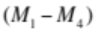 produce and they only supply four wholesalers 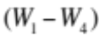 with them.
The number of these items produced by the various manufacturers and supplied to the various wholesalers during a month is shown below by matrix A.
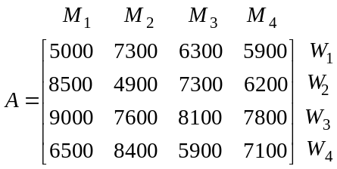

- What is the total number of these items that manufacturer 2 (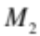) supplies this month?

1 mark

- What is the total number of these items that wholesaler 3 (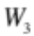) receives this month?

1 mark

The price, in dollars, that each of the manufacturer’s sells these items to the wholesalers for is shown in matrix P below.
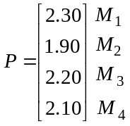

- Evaluate the matrix product 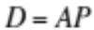.

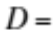

1 mark

- In matrix D, explain what the entry in row 1, column 1 represents.

1 mark
Question 3

A builder purchases three different products for three different projects he is currently completing. A system of linear equations can be written that involve the quantity of the three products used, the cost, x, y and z, in dollars, of each of the three products used together with the total cost of the 3 different products used at each project.

That system of equation is shown below.

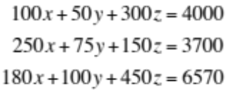

- Complete the matrix equation below which represents this system of equations

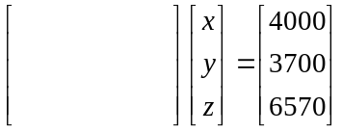
1 mark

- Use this matrix equation to find the costs, 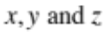 in dollars of each of the three products used.

2 marks
Question 4

A wholesaler supplies two products X and Y to a commercial builder to use in a new project.
At the start of the project the amount, in tonnes, of each of these products supplied by the wholesaler is given by the matrix

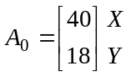

The amount of these two products supplied at the end of week 1 of the project is given by
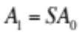where S is the supply matrix and
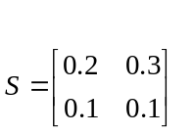
- Find 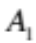.

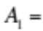

1 mark

The amount of product X and product Y supplied at the end of the nth week of the project is given by the matrix equation 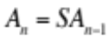

- What amount of product Y will be supplied at the end of the third week of the project. Express your answer in tonnes correct to 2 decimal places.

1 mark

When the total amount (in tonnes) of products X and Y being supplied at the end of a week drops below 0.2 tonne, the wholesaler will charge for delivery.

- At the end of which week does the wholesaler first charge for delivery?

1 mark
At a different project, the wholesaler is supplying the same products X and Y so that the amount, in tonnes, supplied at the end of the nth week is given by the matrix equation

where 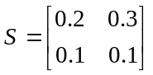 as before.

- If the amount supplied at the end of the second week is given by

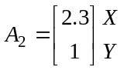

find 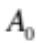, the amount in tonnes of products X and Y supplied initially to this project.

2 marks
Total 15 marks

Further Mathematics Formulas

Core: Data analysis

standardised score: 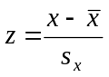
least squares line: 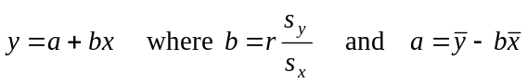
residual value: residual value = actual value – predicted value

seasonal index: seasonal index 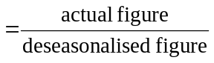

Module 1: Number patterns

arithmetic series: 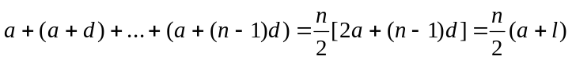
geometric series: 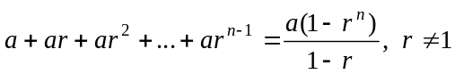
infinite geometric series: 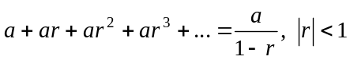

Module 2: Geometry and trigonometry

area of a triangle: 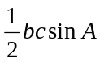
Heron's formula: 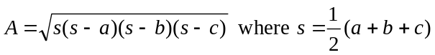
circumference of a circle: 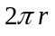

area of a circle: 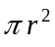

volume of a sphere: 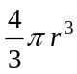
surface area of a sphere: 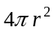

volume of a cone: 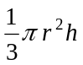
volume of a cylinder: 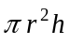

volume of a prism: 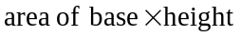
volume of a pyramid: 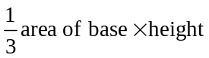

Reproduced with permission of the Victorian Curriculum and Assessment Authority, Victoria, Australia.
These formula sheets have been copied in 2012 from the VCAA website www.vcaa.vic.edu.au
The VCAA publish an exam issue supplement to the VCAA bulletin.
Pythagoras’ theorem 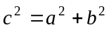

sine rule: 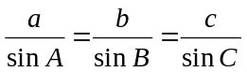
cosine rule: 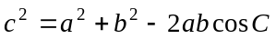

Module 3: Graphs and relations

Straight line graphs
gradient (slope): 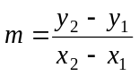
equation: 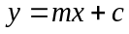

Module 4: Business-related mathematics

simple interest: 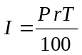
compound interest: 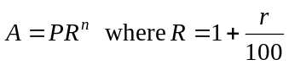
hire purchase: 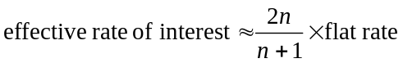

Module 5: Networks and decision mathematics

Euler’s formula: 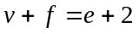

Module 6: Matrices

determinant of a 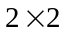 matrix 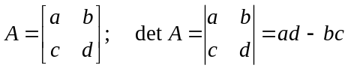
inverse of a matrix 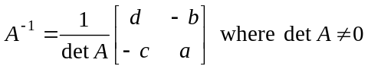

END OF FORMULA SHEET

Reproduced with permission of the Victorian Curriculum and Assessment Authority, Victoria, Australia.
These formula sheets have been copied in 2012 from the VCAA website www.vcaa.vic.edu.au
The VCAA publish an exam issue supplement to the VCAA bulletin.

